UNITED STATES
SECURITIES AND EXCHANGE COMMISSION
Washington, DC 20549

FORM 8-K

Current Report Pursuant
to Section 13 or 15(d) of the
Securities Exchange Act of 1934

Date of Report (Date of earliest event Reported): August 25, 2026

THERAVANCE BIOPHARMA, INC.
(Exact Name of Registrant as Specified in its Charter)

Cayman Islands |  | 001-36033 |  | 98-1226628
(State or Other Jurisdiction of |  | (Commission File Number) |  | (I.R.S. Employer Identification
Incorporation) |  |  |  | Number)

c/o Theravance Biopharma US, LLC
901 Gateway Boulevard
South San Francisco, CA 94080
(650) 808-6000

(Addresses, including zip code, and telephone numbers, including area code, of principal executive offices)

Check the appropriate box below if the Form 8-K filing is intended to simultaneously satisfy the filing obligation of the registrant under any of the following provisions (see General Instruction A.2. below):

☐ Written communications pursuant to Rule 425 under the Securities Act (17 CFR 230.425)
☒ Soliciting material pursuant to Rule 14a-12 under the Exchange Act (17 CFR 240.14a-12)
☐ Pre-commencement communications pursuant to Rule 14d-2(b) under the Exchange Act (17 CFR 240.14d-2(b))
☐ Pre-commencement communications pursuant to Rule 13e-4(c) under the Exchange Act (17 CFR 240.13e-4(c))

Securities registered pursuant to Section 12(b) of the Act:

Title of each class |  | Trading  Symbol(s) |  | Name of each exchange  on which registered
Ordinary Share $0.00001 Par Value |  | TBPH |  | NASDAQ Global Market

Indicate by check mark whether the registrant is an emerging growth company as defined in Rule 405 of the Securities Act of 1933 (§ 230.405 of this chapter) or Rule 12b-2 of the Securities Exchange Act of 1934 (§ 240.12b-2 of this chapter).

Emerging growth company ☐

If an emerging growth company, indicate by check mark if the registrant has elected not to use the extended transition period for complying with any new or revised financial accounting standards provided pursuant to Section 13(a) of the Exchange Act. ☐

Item 8.01. Other Events.

On August 25, 2026, Theravance Biopharma, Inc. (the “Company”) made available a presentation regarding the Phase 3 CYPRESS Study (0197) of ampreloxetine in patients with symptomatic neurogenic orthostatic hypotension (“nOH”) associated with multiple system atrophy (“MSA”), including post hoc analyses of data from the CYPRESS Study (0197) and information regarding the Company’s interactions with the U.S. Food and Drug Administration concerning the ampreloxetine clinical development program. A copy of the presentation is furnished as Exhibit 99.1 to this Current Report on Form 8-K and is incorporated herein by reference.

The information in this Current Report (including Exhibit 99.1) is being furnished and shall not be deemed “filed” for the purposes of Section 18 of the Securities Exchange Act of 1934, as amended, or otherwise subject to the liabilities of that Section. The information in this Current Report (including Exhibit 99.1) shall not be incorporated by reference into any registration statement or other document pursuant to the Securities Act of 1933, as amended, except as shall be expressly set forth by specific reference in such filing.

Item 9.01. Financial Statements and Exhibits.

(d) Exhibits.

99.1 | Slide presentation entitled CYPRESS Study 0197 Update
104 | Cover Page Interactive Data File (cover page XBRL tags embedded within the Inline XBRL document)

Cautionary Statement Regarding Forward-Looking Statements

This Current Report on Form 8-K includes “forward-looking statements” within the meaning of federal securities laws, including safe harbor provisions of the Private Securities Litigation Reform Act of 1995, Section 27A of the Securities Act and Section 21E of the Exchange Act, as amended. Such forward-looking statements involve risks, uncertainties, and assumptions. All statements in this report, other than statements of historical facts, including statements regarding our strategy, future operations, future financial position, future revenues, projected costs, prospects, plans, intentions, designs, expectations and objectives, the interpretation of post hoc and exploratory CYPRESS analyses, the potential treatment effect and regulatory path for ampreloxetine, and the design, financing, conduct, results and regulatory sufficiency of any additional clinical trial or marketing application, are forward-looking statements. The words “aim,” “anticipate,” “assume,” “believe,” “contemplate,” “continue,” “could,” “designed,” “developed,” “drive,” “estimate,” “expect,” “forecast,” “goal,” “indicate,” “intend,” “may,” “mission,” “opportunities,” “plan,” “possible,” “potential,” “predict,” “project,” “pursue,” “represent,” “seek,” “suggest,” “should,” “target,” “will,” “would,” and similar expressions (including the negatives thereof) are intended to identify forward-looking statements, although not all forward-looking statements contain these identifying words. These statements reflect our current views with respect to future events or our future financial performance, are based on assumptions, projections, estimates, expectations and beliefs, and involve known and unknown risks, uncertainties and other factors which may cause our actual results, performance or achievements to be materially different from any future results, performance or achievements expressed or implied by the forward-looking statements. No forward-looking statement can be guaranteed. Actual results may differ materially from current expectations because of numerous risks and uncertainties including, but not limited to, (i) the approval of the Company’s shareholders for the proposed transaction between the Company and Zymeworks Inc. (“Parent”) previously announced on June 29, 2026, which may be delayed or may not be obtained, (ii) when the contingent consideration under the contingent value right agreement to be entered into by Parent and a third party rights agent will become payable, if at all, (iii) the risks inherent in the drug development process, including whether the development of the compound subject to the contingent value right agreement will be commercially successful, (iv) the risk that the expected benefits of the proposed transaction will not be realized, (v) potential litigation relating to the proposed transaction that could be instituted against the Company or its directors or officers, including the effects of any outcomes related thereto, (vi) any competing offers or acquisition proposals for the Company, (vii) the possibility that various conditions to the consummation of the proposed transaction may not be satisfied or waived and (viii) unanticipated difficulties or expenditures relating to the proposed transaction, the response of business partners and competitors to the announcement of the proposed transaction, including with respect to the Company’s collaboration with Viatris Inc., and/or potential difficulties in employee retention as a result of the announcement and pendency of the proposed transaction and (ix) risks related to potential restructuring activities in connection with the proposed transaction, including disruptions to the Company’s recognition or utilization of certain tax attributes. Ampreloxetine-specific risks include that post hoc and exploratory analyses may not be replicated or predict clinical benefit; the FDA may reject a proposed study design or require additional trials or data; any additional pivotal trial may be delayed, unsuccessful or insufficient to support approval; resources or third-party interest needed to develop, partner, license or otherwise monetize ampreloxetine may not be available; and no marketing application may be submitted or approved. In addition, ampreloxetine is subject to the risks inherent in drug development, and there can be no assurance that its further development will be pursued or clinically, regulatorily or commercially successful. Forward-looking statements in this Current Report on Form 8-K should be evaluated together with the many uncertainties that affect the Company’s business, particularly the risk factors discussed in Part I, Item 1A of the Company’s most recent Annual Report on Form 10-K under the heading “Risk Factors,” and Parent’s business, particularly the risk factors discussed in Part I, Item 1A of Parent’s most recent Annual Report on Form 10-K under the heading “Risk Factors,” as well as other documents that may be filed by the Company or Parent from time to time with the United States Securities and Exchange Commission (“SEC”). Neither the Company nor Parent undertakes any obligation to publicly update any forward-looking statement, whether as a result of new information, future events or otherwise. The forward-looking statements made in this Current Report on Form 8-K relate only to events as of the date on which the statements are made.

Important Information and Where to Find It

In connection with the proposed transaction involving the Company and Parent, the Company has filed with the SEC a definitive proxy statement on Schedule 14A on August 21, 2026 (the “Definitive Proxy Statement”). This communication is not a substitute for the Definitive Proxy Statement or any other document that may be filed by the Company with the SEC. THE COMPANY’S SHAREHOLDERS AND INVESTORS ARE URGED TO READ THE DEFINITIVE PROXY STATEMENT IN ITS ENTIRETY AND ANY OTHER DOCUMENTS FILED BY THE COMPANY WITH THE SEC IN CONNECTION WITH THE PROPOSED TRANSACTION OR INCORPORATED BY REFERENCE THEREIN BECAUSE THEY CONTAIN OR WILL CONTAIN IMPORTANT INFORMATION ABOUT THE PROPOSED TRANSACTION AND THE PARTIES TO THE PROPOSED TRANSACTION. Investors and shareholders may obtain a free copy of the Definitive Proxy Statement and such other documents containing important information about the Company through the website maintained by the SEC at www.sec.gov. The Company makes available free of charge at the Company’s website at https://investor.theravance.com/sec-filings copies of materials it files with, or furnishes to, the SEC.

Participants in the Solicitation

This communication does not constitute a solicitation of proxy, an offer to purchase or a solicitation of an offer to sell any securities. The Company and its directors, executive officers and certain employees may be deemed to be participants in the solicitation of proxies from the shareholders of the Company in connection with the proposed transaction. The Company’s shareholders may obtain additional information regarding the direct and indirect interests of the participants in the solicitation of proxies in connection with the proposed transaction, including the interests of the Company’s directors and executive officers in the proposed transaction, which may be different from those of the Company’s shareholders generally, by reading the Definitive Proxy Statement and any other relevant documents that are filed or will be filed with the SEC in connection with the proposed transaction when they become available. These documents (when available) may be obtained free of charge from the SEC’s website at www.sec.gov, the Company’s website at www.theravance.com.

SIGNATURE

Pursuant to the requirements of the Securities Exchange Act of 1934, the registrant has duly caused this report to be signed on its behalf by the undersigned hereunto duly authorized.

 | THERAVANCE BIOPHARMA, INC.
Date: August 25, 2026 | By: | /s/ Brett Grimaud
 |  | Brett Grimaud
 |  | General Counsel

Exhibit 99.1

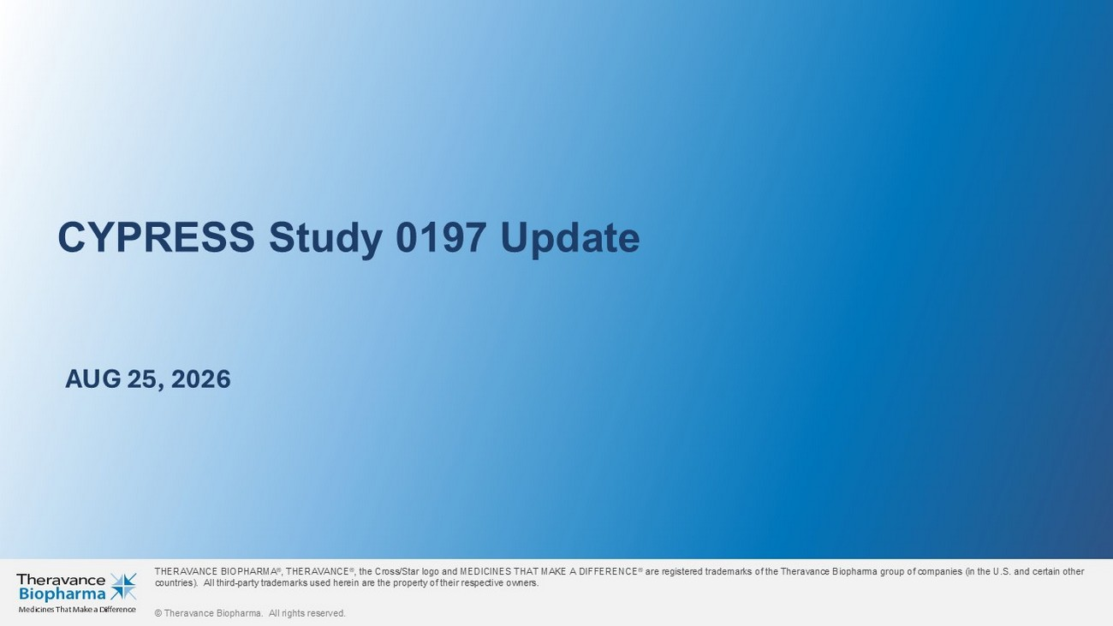
CYPRESS Study 0197 Update THERAVANCE BIOPHARMA ® , THERAVANCE ® , the Cross/Star logo and MEDICINES THAT MAKE A DIFFERENCE ® are registered trademarks of the Theravance Biopharma group of companies (in the U.S. and certain other countries). All third - party trademarks used herein are the property of their respective owners. © Theravance Biopharma. All rights reserved. AUG 25 , 2026

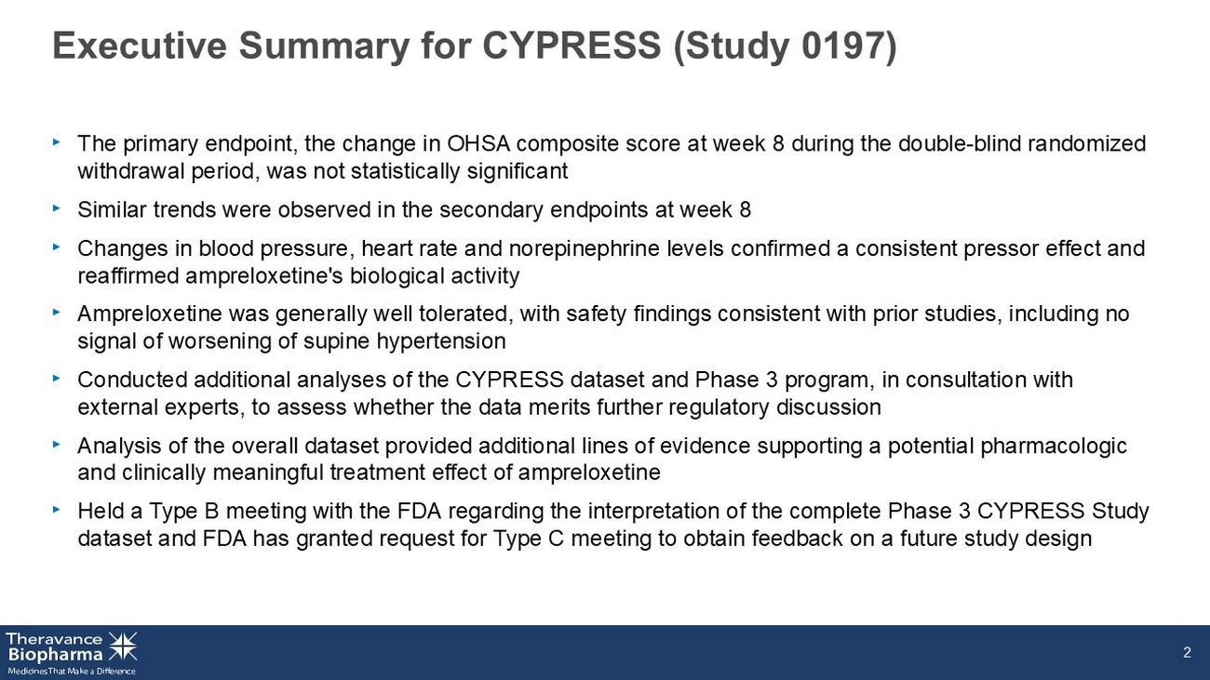
Executive Summary for CYPRESS (Study 0197 ) ‣ The primary endpoint, the change in OHSA composite score at week 8 during the double - blind randomized withdrawal period, was not statistically significant ‣ Similar trends were observed in the secondary endpoints at week 8 ‣ Changes in blood pressure, heart rate and norepinephrine levels confirmed a consistent pressor effect and reaffirmed ampreloxetine's biological activity ‣ Ampreloxetine was generally well tolerated, with safety findings consistent with prior studies, including no signal of worsening of supine hypertension ‣ Conducted additional analyses of the CYPRESS dataset and Phase 3 program, in consultation with external experts, to assess whether the data merits further regulatory discussion ‣ Analysis of the overall dataset provided additional lines of evidence supporting a potential pharmacologic and clinically meaningful treatment effect of ampreloxetine ‣ Held a Type B meeting with the FDA regarding the interpretation of the complete Phase 3 CYPRESS Study dataset and FDA has granted request for Type C meeting to obtain feedback on a future study design 2

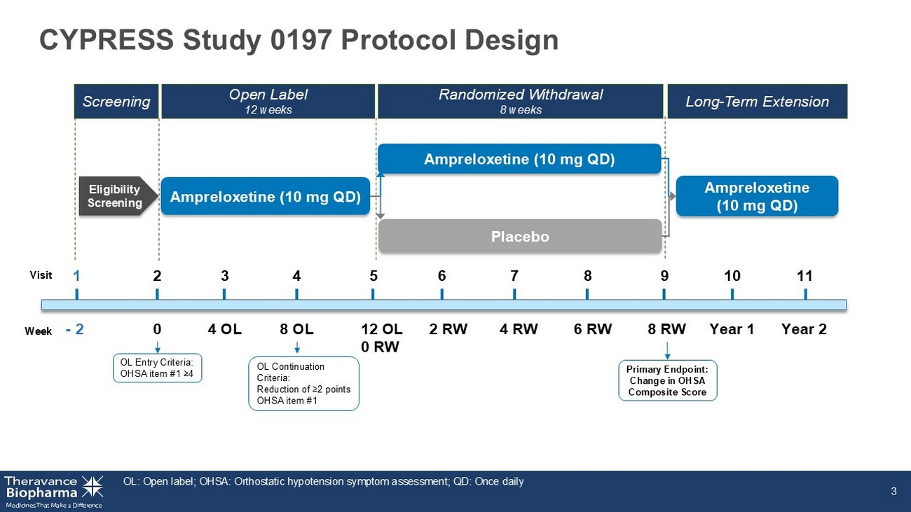
CYPRESS Study 0197 Protocol Design OL: Open label; OHSA: Orthostatic hypotension symptom assessment; QD: Once daily 3 Ampreloxetine (10 mg QD) Placebo Eligibility Screening 0 8 OL 12 OL 0 RW 2 RW 6 RW Year 1 - 2 4 RW 8 RW Visit 1 6 4 10 2 5 7 8 9 3 4 OL Week Ampreloxetine (10 mg QD) Ampreloxetine (10 mg QD) 11 Year 2 Screening Open Label 12 weeks Randomized Withdrawal 8 weeks Long - Term Extension OL Entry Criteria: OHSA item #1 ≥4 OL Continuation Criteria: Reduction of ≥2 points OHSA item #1 Primary Endpoint: Change in OHSA Composite Score

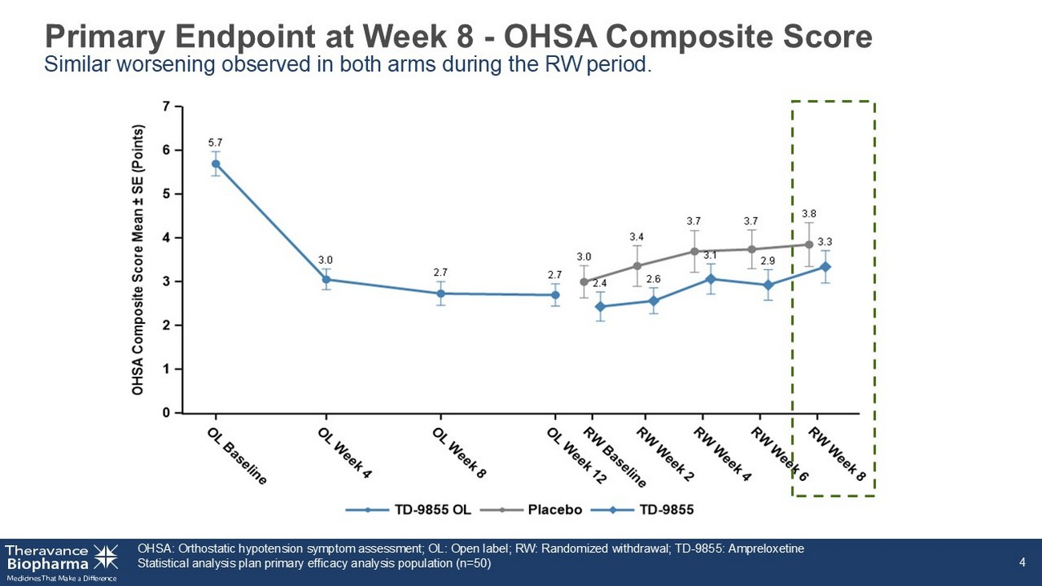
Primary Endpoint at Week 8 - OHSA Composite Score Similar worsening observed in both arms during the RW period. OHSA: Orthostatic hypotension symptom assessment; OL: Open label; RW: Randomized withdrawal; TD - 9855: Ampreloxetine Statistical analysis plan primary efficacy analysis population (n=50) 4

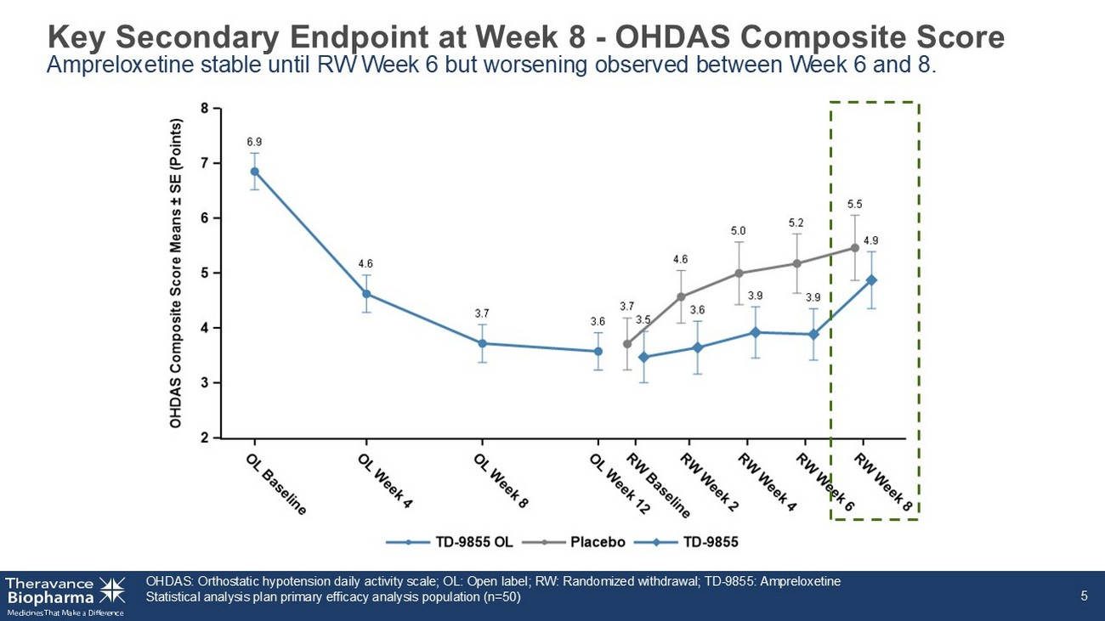
Key Secondary Endpoint at Week 8 - OHDAS Composite Score Ampreloxetine stable until RW Week 6 but worsening observed between Week 6 and 8. OHDAS: Orthostatic hypotension daily activity scale; OL: Open label; RW: Randomized withdrawal; TD - 9855: Ampreloxetine Statistical analysis plan primary efficacy analysis population (n=50) 5

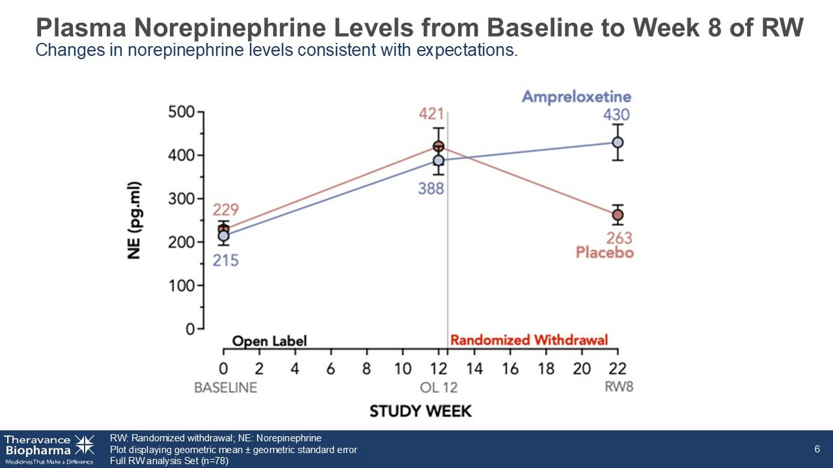
Plasma Norepinephrine Levels from Baseline to Week 8 of RW Changes in norepinephrine levels consistent with expectations. RW: Randomized withdrawal; NE: Norepinephrine Plot displaying geometric mean ± geometric standard error Full RW analysis Set (n=78) 6

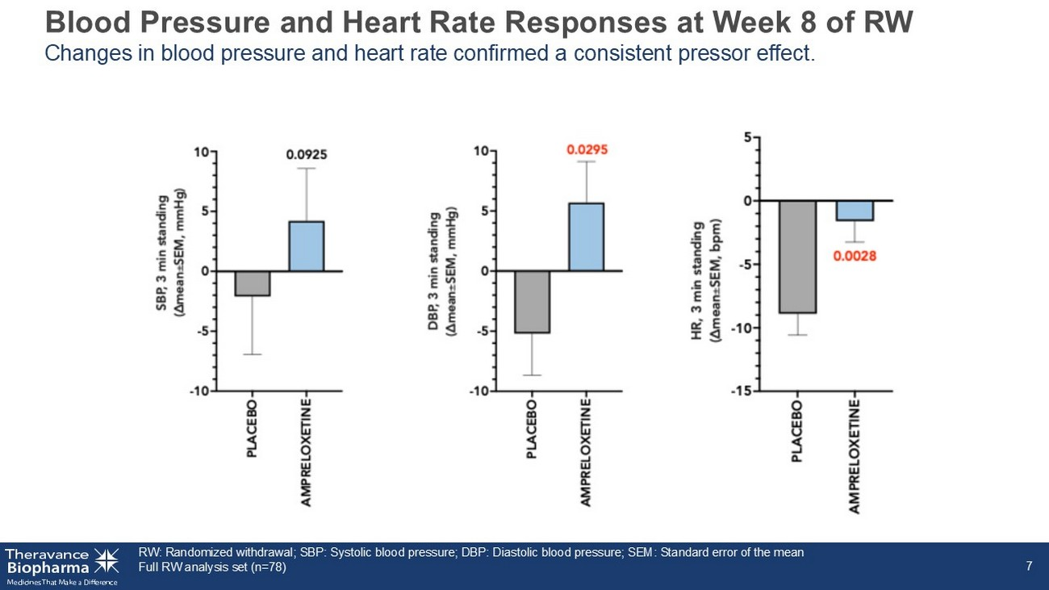
Blood Pressure and Heart Rate Responses at Week 8 of RW Changes in blood pressure and heart rate confirmed a consistent pressor effect. RW: Randomized withdrawal; SBP: Systolic blood pressure; DBP: Diastolic blood pressure; SEM: Standard error of the mean Full RW analysis set (n=78) 7

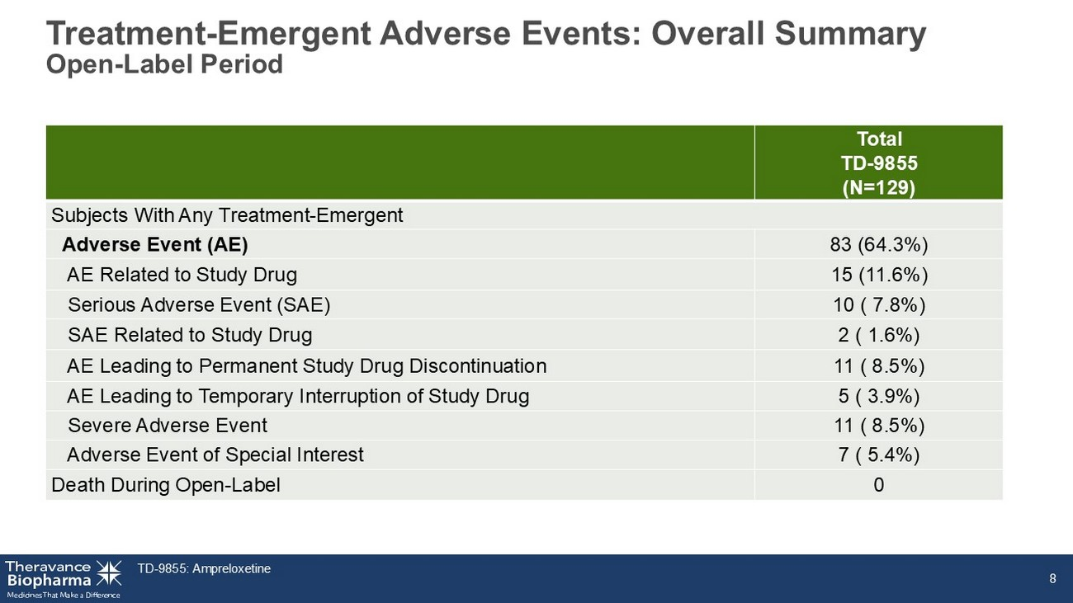
8 Total TD - 9855 (N=129) Subjects With Any Treatment - Emergent 83 (64.3%) Adverse Event (AE) 15 (11.6%) AE Related to Study Drug 10 ( 7.8%) Serious Adverse Event (SAE) 2 ( 1.6%) SAE Related to Study Drug 11 ( 8.5%) AE Leading to Permanent Study Drug Discontinuation 5 ( 3.9%) AE Leading to Temporary Interruption of Study Drug 11 ( 8.5%) Severe Adverse Event 7 ( 5.4%) Adverse Event of Special Interest 0 Death During Open - Label TD - 9855: Ampreloxetine Treatment - Emergent Adverse Events: Overall Summary Open - Label Period

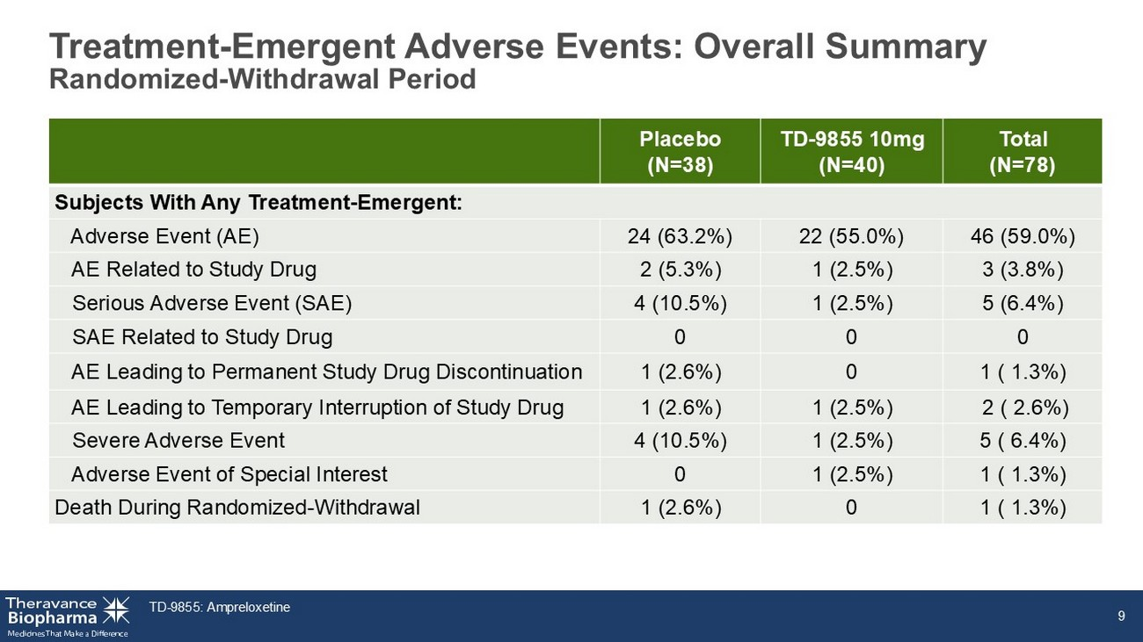
TD - 9855: Ampreloxetine 9 Total (N=78) TD - 9855 10mg (N=40) Placebo (N=38) Subjects With Any Treatment - Emergent: 46 (59.0%) 22 (55.0%) 24 (63.2%) Adverse Event (AE) 3 (3.8%) 1 (2.5%) 2 (5.3%) AE Related to Study Drug 5 (6.4%) 1 (2.5%) 4 (10.5%) Serious Adverse Event (SAE) 0 0 0 SAE Related to Study Drug 1 ( 1.3%) 0 1 (2.6%) AE Leading to Permanent Study Drug Discontinuation 2 ( 2.6%) 1 (2.5%) 1 (2.6%) AE Leading to Temporary Interruption of Study Drug 5 ( 6.4%) 1 (2.5%) 4 (10.5%) Severe Adverse Event 1 ( 1.3%) 1 (2.5%) 0 Adverse Event of Special Interest 1 ( 1.3%) 0 1 (2.6%) Death During Randomized - Withdrawal Treatment - Emergent Adverse Events: Overall Summary Randomized - Withdrawal Period


CYPRESS Post Hoc Data Analyses

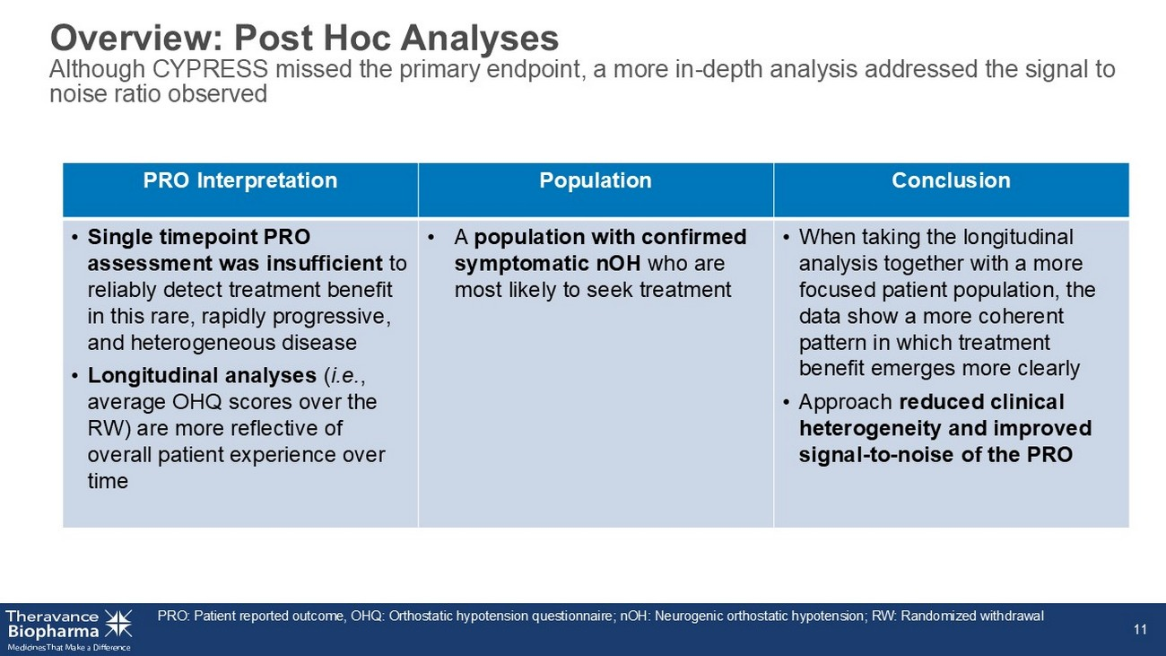
Overview: Post Hoc Analyses Although CYPRESS missed the primary endpoint, a more in - depth analysis addressed the signal to noise ratio observed PRO: Patient reported outcome, OHQ: Orthostatic hypotension questionnaire; nOH: Neurogenic orthostatic hypotension; RW: Rando miz ed withdrawal 11 Conclusion Population PRO Interpretation • When taking the longitudinal analysis together with a more focused patient population, the data show a more coherent pattern in which treatment benefit emerges more clearly • Approach reduced clinical heterogeneity and improved signal - to - noise of the PRO • A population with confirmed symptomatic nOH who are most likely to seek treatment • Single timepoint PRO assessment was insufficient to reliably detect treatment benefit in this rare, rapidly progressive, and heterogeneous disease • Longitudinal analyses ( i.e. , average OHQ scores over the RW) are more reflective of overall patient experience over time

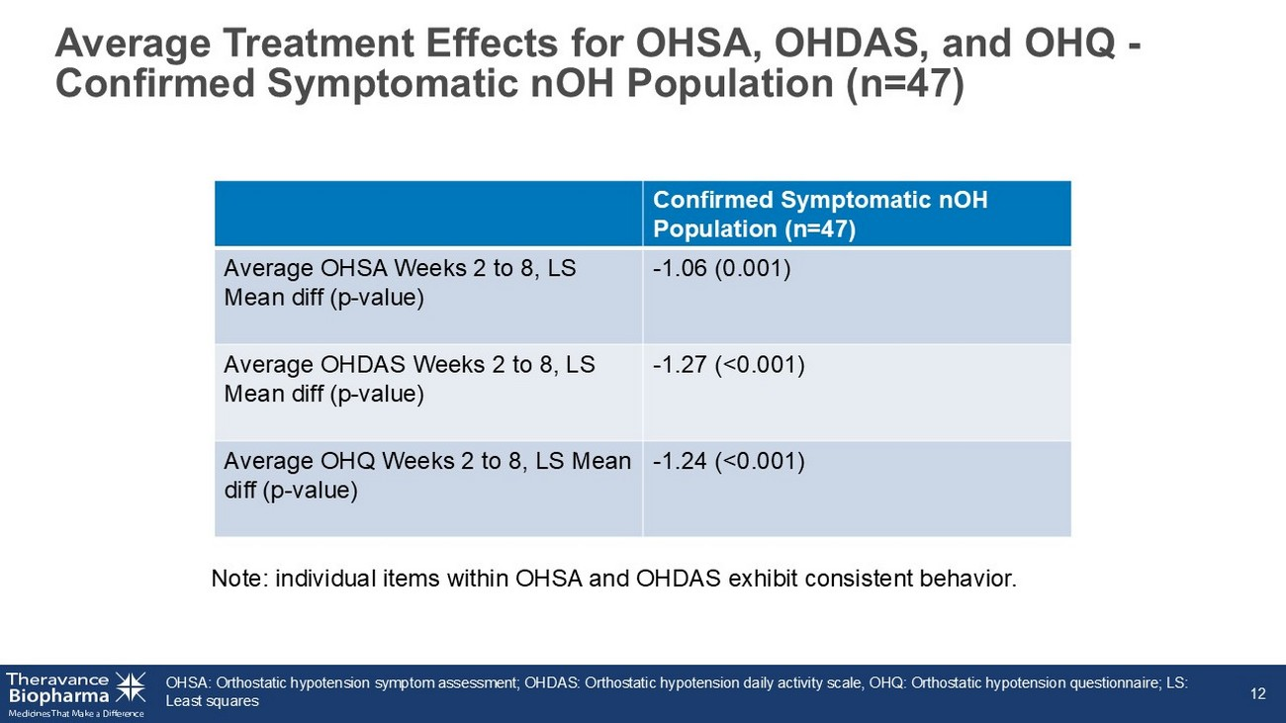
OHSA: Orthostatic hypotension symptom assessment; OHDAS: Orthostatic hypotension daily activity scale, OHQ: Orthostatic hypotens ion questionnaire; LS: Least squares 12 Average Treatment Effects for OHSA, OHDAS, and OHQ - Confirmed Symptomatic nOH Population (n=47) Confirmed Symptomatic nOH Population (n=47) - 1.06 (0.001) Average OHSA Weeks 2 to 8, LS Mean diff (p - value) - 1.27 (<0.001) Average OHDAS Weeks 2 to 8, LS Mean diff (p - value) - 1.24 (<0.001) Average OHQ Weeks 2 to 8, LS Mean diff (p - value) Note: individual items within OHSA and OHDAS exhibit consistent behavior.

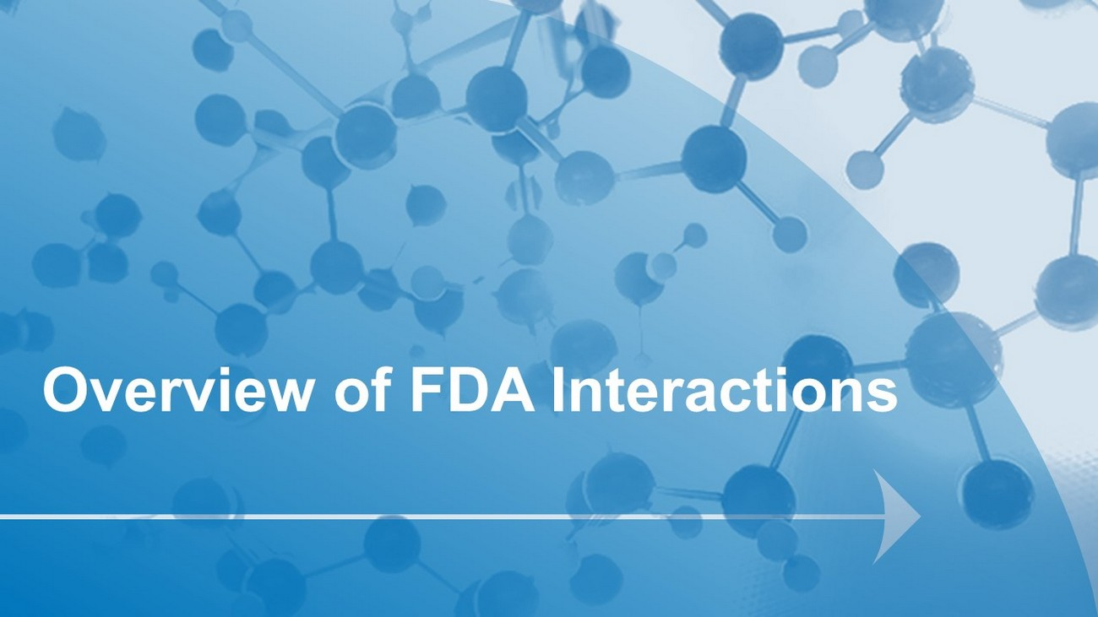
Overview of FDA Interactions

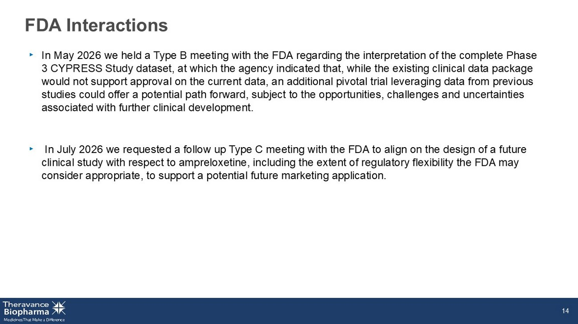
FDA Interactions ‣ In May 2026 we held a Type B meeting with the FDA regarding the interpretation of the complete Phase 3 CYPRESS Study dataset, at which the agency indicated that, while the existing clinical data package would not support approval on the current data, an additional pivotal trial leveraging data from previous studies could offer a potential path forward, subject to the opportunities, challenges and uncertainties associated with further clinical development. ‣ In July 2026 we requested a follow up Type C meeting with the FDA to align on the design of a future clinical study with respect to ampreloxetine, including the extent of regulatory flexibility the FDA may consider appropriate, to support a potential future marketing application. 14

